Domain: College Student Management System
Problem Statement Assume that you are an Data Analyst you need to analyze a college which maintains students, courses, marks.
Level 1: Very Basic
- Display all students.
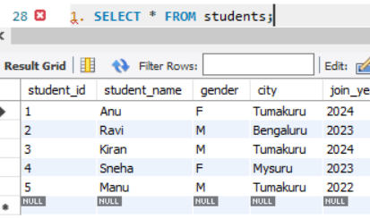
- Display only student_name and city from students table.
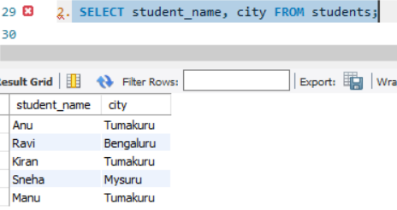
- Show all courses.
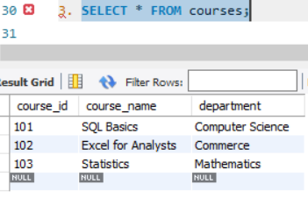
- Display students who are from Tumakuru.
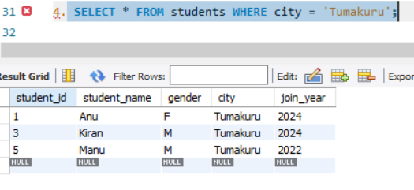

- Display students who joined in 2024.
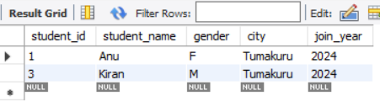
Level 2: Filtering
- Show students whose gender is F.
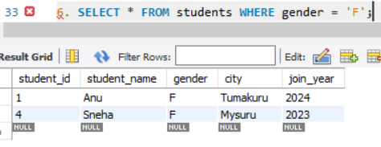
- Show marks greater than 80.
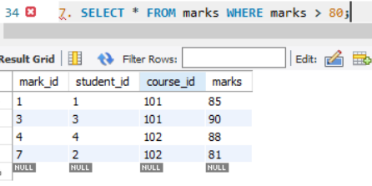
- Display course names from Commerce department.
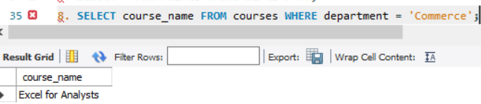
- Show students who are not from Bengaluru.
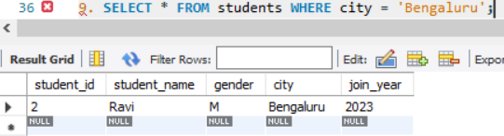
- Display marks between 70 and 90.
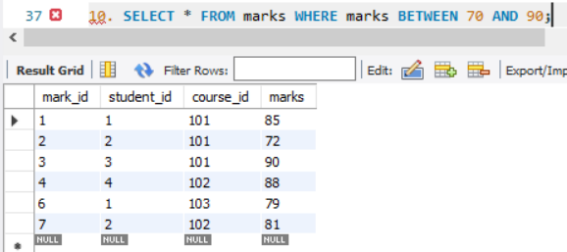
Level 3: Sorting
- Display all students ordered by student_name ascending.
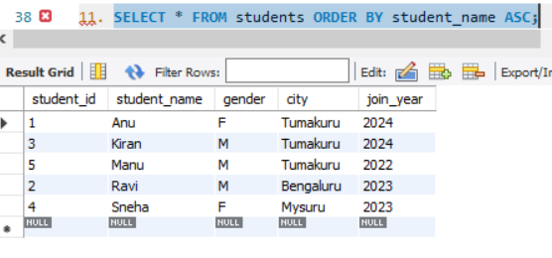
- Show marks ordered from highest to lowest.
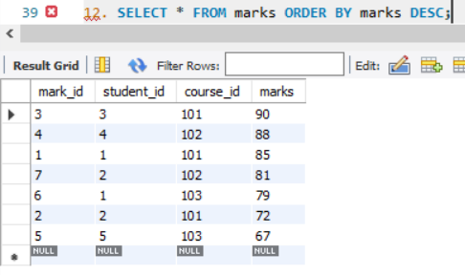
- Display students ordered by join_year descending.
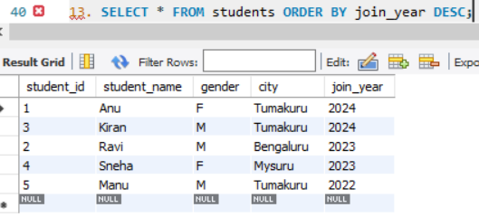
Level 4: Aggregate Basics
- Find total number of students.
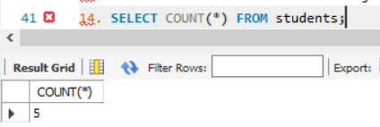
- Find average marks.
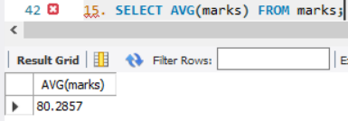

- Find highest marks.
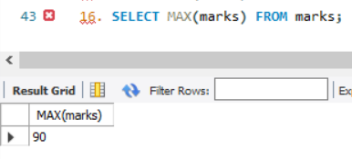
- Find lowest marks.
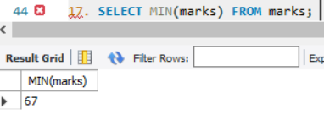

- Find total marks scored by all students.
